**105. Why would you Need Services?**

* -: Here's an example app which you can find attached to this lecture.
* Here we can create some accounts.
* You'll see we start with free accounts here at the bottom.
* We can switch the status of these accounts and you can see that whenever I switch it, I lock something to the console.
* You can also see that this gets locked, locked if I create a new account here.
* And overall what we got here is the ***logging and the data storage.***
* So in general tasks which might be centralized.
* *We also communicate between these components.*
* That's another area where services can be really helpful.
* Cause let's have a look at our code.
* I got free components, *the app component, then the account and the new account component.*
* The app component is where all comes together.
* 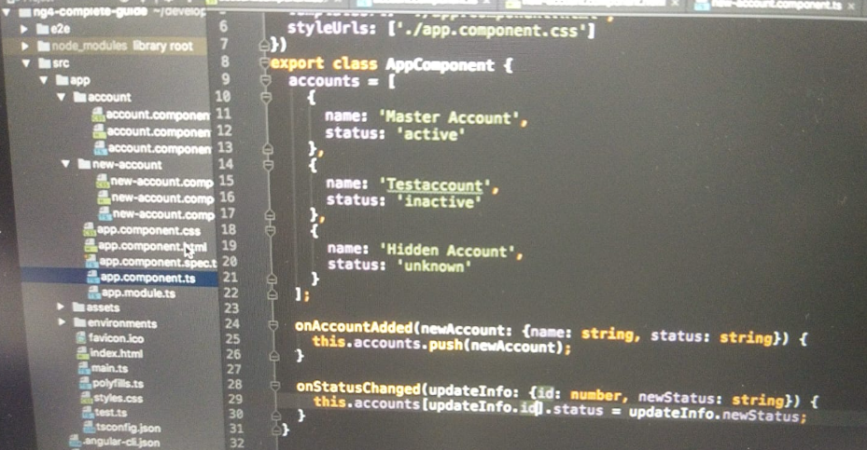
* There in the template I embed the app new account, and the app account component.
* Text

  Description automatically generated
* And I use property and event binding to pass data around.
* For example, I loop through all accounts which are right now stored in the app account in the app component here.
* And I passed them via property binding to the app account component here.

* And there on the other hand, I have an event which gets fired when I click one of the free change the status buttons which is submitted here, which will be catched by my app component where I then handle it again.

* Text

  Description automatically generated
* So I do have event binding to be informed in my app component whenever something changes in the account component.
* Pretty much the same happens in the new account component.
* There I can also listen to a click when I create a new account.
* And on such a click I emit some data, to the app component.
* So this is all fine but we already get quite a complex setup here to pass data around, and that even though that it's still relatively simple it's not a complex app here after all.
* Now in this lecture, we're going to see how services can help us with that and what we have to watch out for.
* So let's dive into it, and build our first service in the next lecture.